
Draft Agenda

March 5, 2025
7:00 – 8:30 pm

- Meeting Called to Order – Rich Van Buskirk (Proxy for Sara Burke Kral)
- Introductions
- Review and Approval of Agenda – Rich Van Buskirk
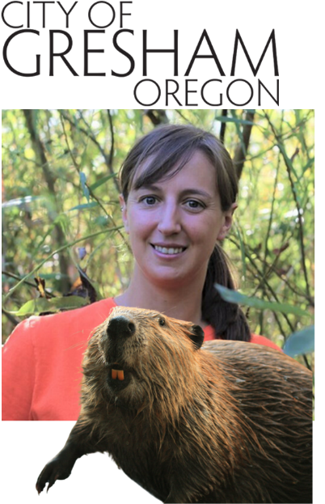
- PRESENTATION: How Beavers Improve Water Quality, Temperatures, and Stream Complexity in an Urban Watershed

- Katie Holzer | Watershed Scientist, City of Gresham
Katie conducts research on the interactions of humans, wildlife and water quality. She has a Ph.D. in Ecology and has been studying urban ecosystems for 13 years.

- PRESENTATION: West Willamette Watersheds Collaboration
- Jack Halsey | Lake Oswego Watershed Council
- Alexis Barton Castro | Tyron Creek Watershed Council

- Public Comment
- Approval of December 2024 Minutes – ACTION REQUESTED
- Final Nominations - 2025 Slate of Officer – ACTION REQUESTED
- Lisa Huntington, Vice Chair
- Mark Fitzsimons, Secretary

- New Council Member (Cities): Peter Brandom, City of Cornelius replacing Rahim Harji, City of Hillsboro
ACTION REQUESTED
Peter Brandom Bio
Peter was appointed City Manager of Cornelius in 2022. He joined Cornelius at an interesting time, given the community’s recent significant residential population growth. Previously Peter was Senior Program Manager at City of Hillsboro for 14 years, where he developed and managed the City’s environmental sustainability program and managed solid waste, smart city, and other programs and projects. Peter earned a Master of Science degree from University of Edinburgh, grew up in the Colorado mountains (go Nuggets) and earned his undergraduate degree from University of Denver.

- Adjourn

